**1] Angular JS libraries and Framework -- Model View Controller , Angular JS modules , ngApp directive , Document Object Model**

* <https://angularjs.org/>
* <https://www.youtube.com/user/angularjs>
* <https://www.youtube.com/watch?v=zKkUN-mJtPQ&list=PL6n9fhu94yhWKHkcL7RJmmXyxkuFB3KSl> (**Youtube**)

**2] Virtual lab issues**

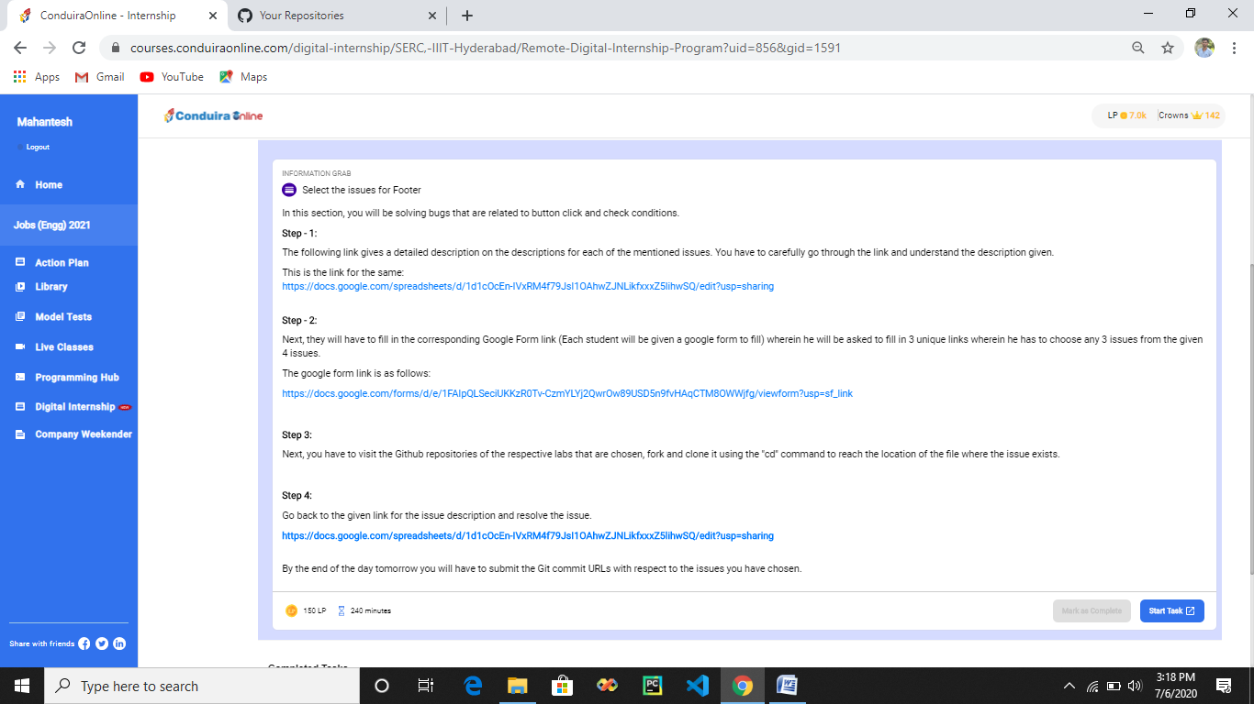

* <https://docs.google.com/spreadsheets/d/1d1cOcEn-IVxRM4f79JsI1OAhwZJNLikfxxxZ5lihwSQ/edit?usp=sharing>
* <https://docs.google.com/forms/d/e/1FAIpQLSeciUKKzR0Tv-CzmYLYj2QwrOw89USD5n9fvHAqCTM8OWWjfg/viewform?usp=sf_link>

**3] More on Angular JS :- Angular JS bootstrapping , Rootscope , Angular component, Transforming data using pipes**

* <https://www.tutorialspoint.com/angularjs/index.htm>

**4] Experiment – Make a list of Functionality**

* [**https://docs.google.com/document/d/1aoP6nuoEGe4Rhfu1gek5WL8WI5re71X-qnwJq7VeT0A/edit?usp=sharing**](https://docs.google.com/document/d/1aoP6nuoEGe4Rhfu1gek5WL8WI5re71X-qnwJq7VeT0A/edit?usp=sharing)
* [**http://cl-iiith.vlabs.ac.in/exp2/index.html#**](http://cl-iiith.vlabs.ac.in/exp2/index.html#)

